Section 1: Setup & Configuration

- git config --global user.name "Your Name"
Description: Sets the name that will be identifiable for credit when reviewing version history.

- git config --global user.email "your.email@example.com"
Description: Sets an email address that will be associated with each history marker.

- git config --global color.ui auto
Description: Sets automatic command line coloring for Git for easy reviewing.
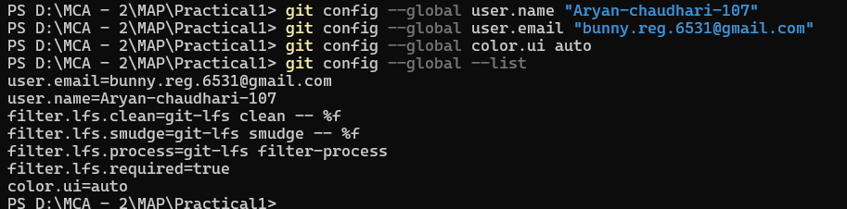

- git init
Description: Initializes an existing directory as a Git repository.
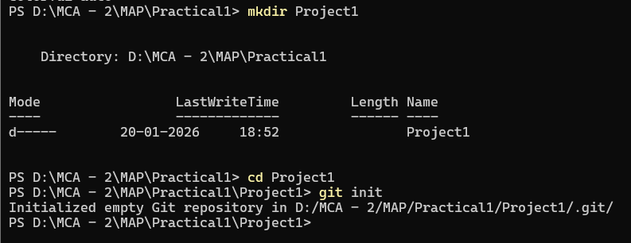

What it’s contain inside .git folder??
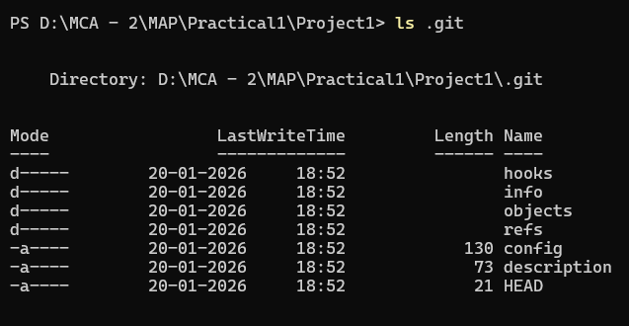

Section 2: Stage & Snapshot

- git status
Description: Shows modified files in working directory that are staged for your next commit.
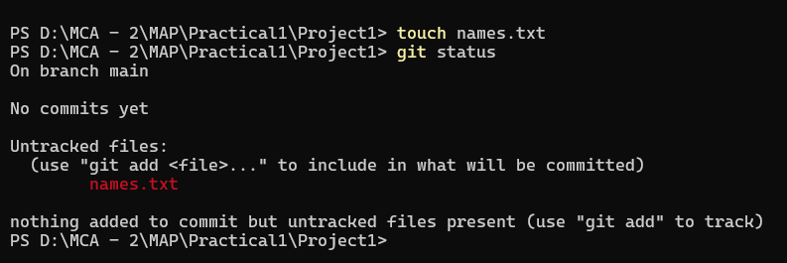
It’s showing red (name.txt) cuz it has not added (staged).

- git add [file] or git add .
Description: Adds a file as it looks now to your next commit (stage).
Here This dot will add all red files that are not staged. Doesn’t matter how many file are there
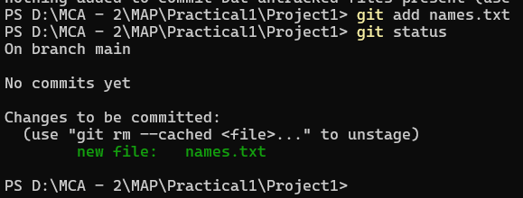
“Just a reference for future concept”
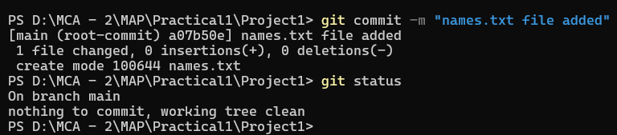
- git reset [file]
Description: Unstages a file while retaining the changes in working directory.
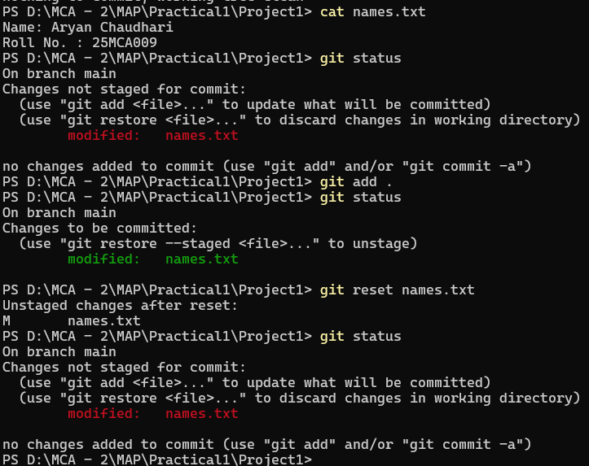

- git diff (Here git diff is not showing anything cuz I have staged names.txt)
Description: Shows the difference of what is changed but not staged.
- git diff --staged
Description: Shows the difference between what is staged but not yet committed.
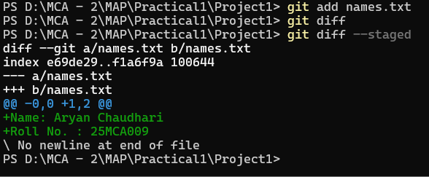
- git commit -m "[descriptive message]"
Description: Commits your staged content as a new commit snapshot. (snapshot is taken)
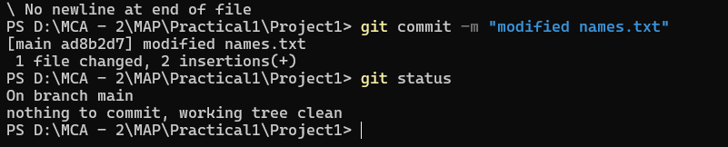

Section 3: Commit History, Remove File & Reset Commit
- git log
Description: Shows all commits in the current branch's history.
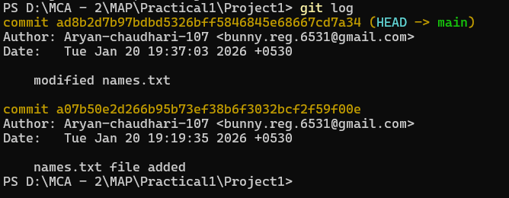

- git rm [file]
Description: Deletes the file from project and stages the removal for commit.
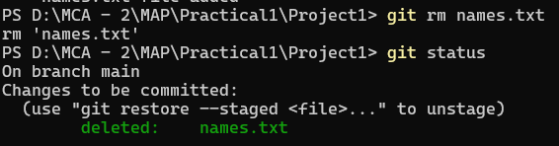
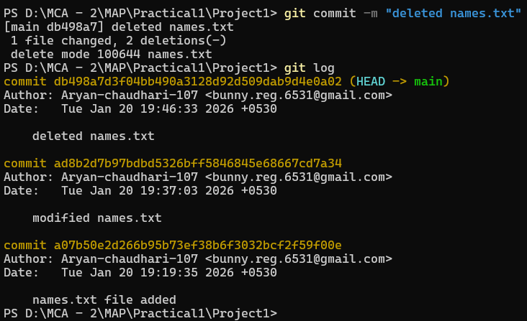
NOTE: I deleted this square bracket part by mistake. I didn’t want to do it. I want to remove
This comment from my history
Each commit builds on top of the others
Let’s say I want to go back to any particular history, like on “Tue Jan 20 19:19:35 2026”
Now understand:
If I want to rollback to here “Tue Jan 20 19:19:35 2026”, I will select this commit ID
(Or)
If I want to remove the upper two commit I will select the below commit (first commit)
(Just copy the commit ID)

- git reset [commit ID]
Description: Moves the branch to the given commit, keeps changes in the working directory, but unstages them.
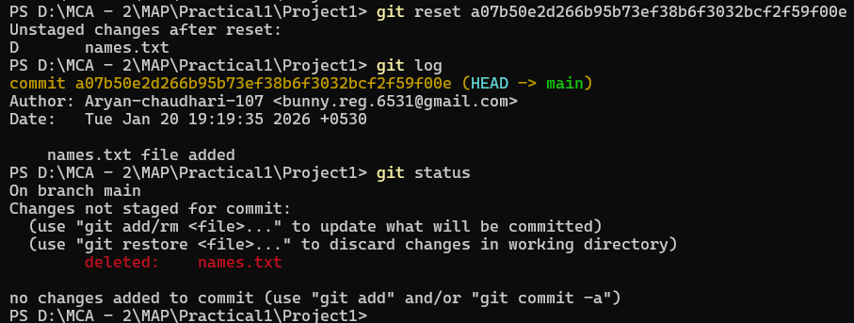
- git reset --hard [commit ID]
Description: Moves the branch to the given commit and discards all changes in both the staging area and working directory..

Section 4: Temporary Commits

Now I want to save all these changes, but I do not want to commit so my history looks clean
And I also don’t want to lose my changes
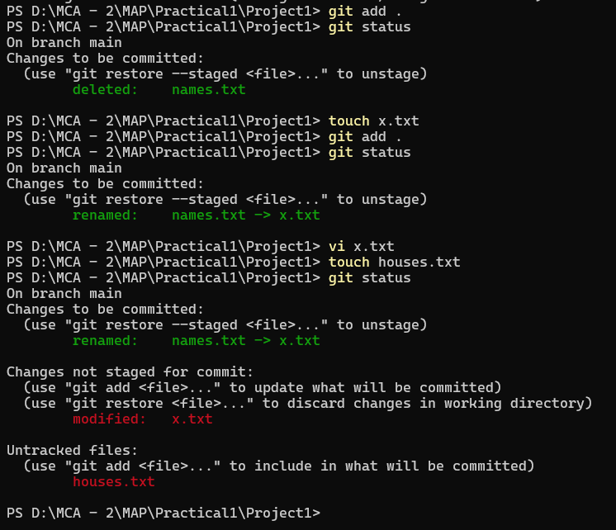

These changes are added (it’s not in Screen Shot). Now I'm going to perfume temporary commits

- git stash
Description: Saves modified and staged changes.
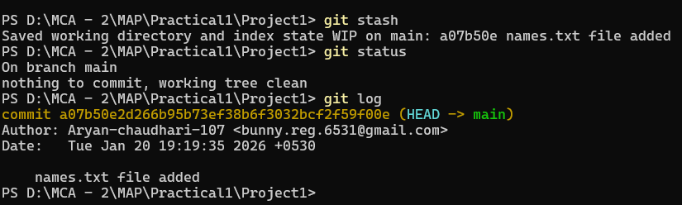
(Same as Previous)

- git stash pop
Description: Writes working from top of stash stack.
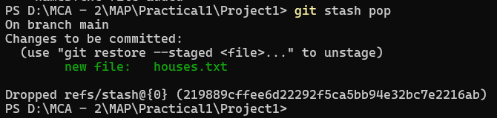

- git stash list
Description: Lists the stack order of stashed file changes.
- git stash clear
Description: clear everything from the stash
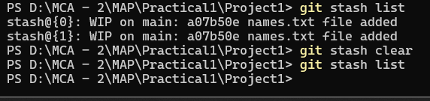
Section 5: Share & Update

- git remote add [alias] [url]
Description: Adds a git URL as an alias
If no alias is chosen, origin is conventionally used as the default name for the remote URL.
- git remote -v
Description: displays the list of configured remote repositories along with their fetch and push URLs.

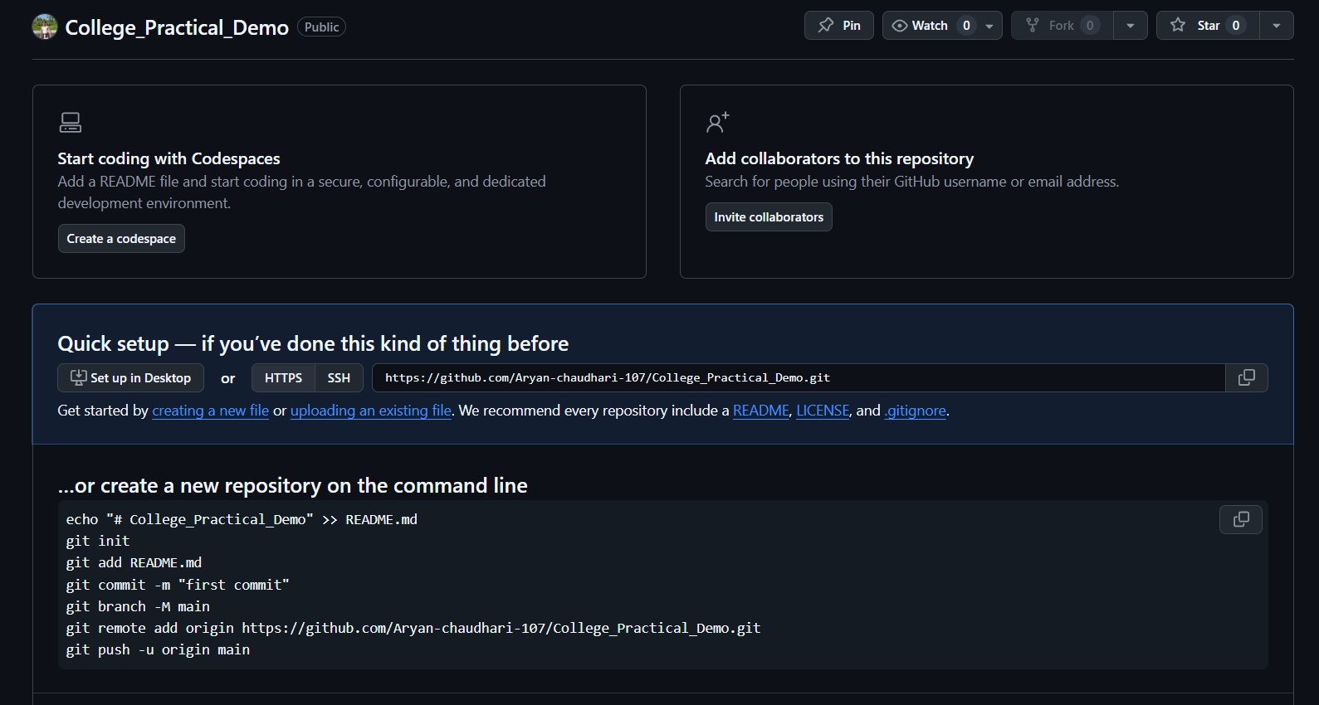
Repo, which I have created on my GitHub

- git push [alias] [branch]
Description: Transmits local branch commits to the remote repository branch.
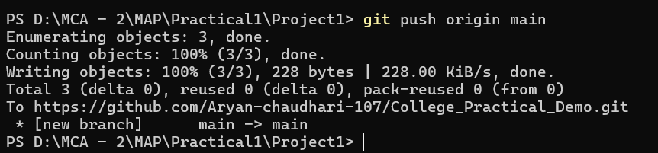
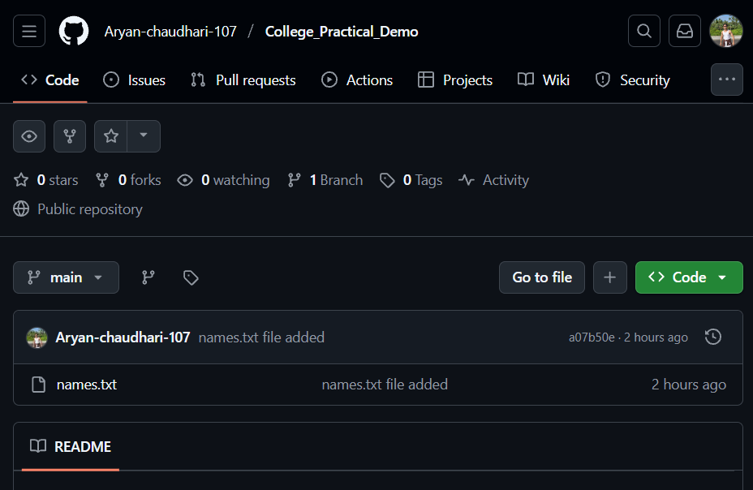
names.txt is now on our remote repo

This is the only one commit that I have pushed on remote repo.
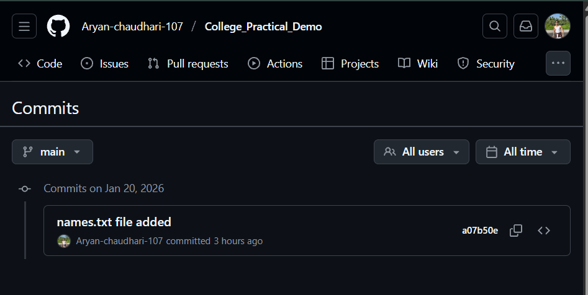

I have created some random txt files and commited on local repo, but I have not pushed, so they are limited to the local repo
Which you can understand from the screenshot below: look, there is the original main on commite that I have pushed on the remote repo.
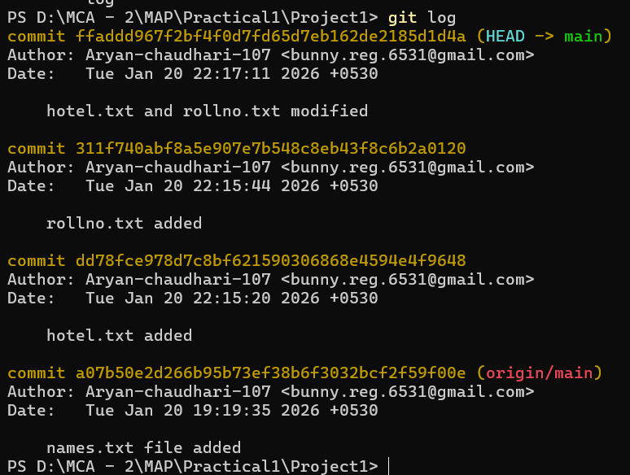
Now I want to push this commit on main branch on remote repo
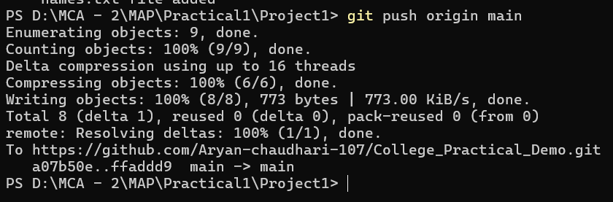

In the screenshot below, you can see all commit pushed on remote repo:
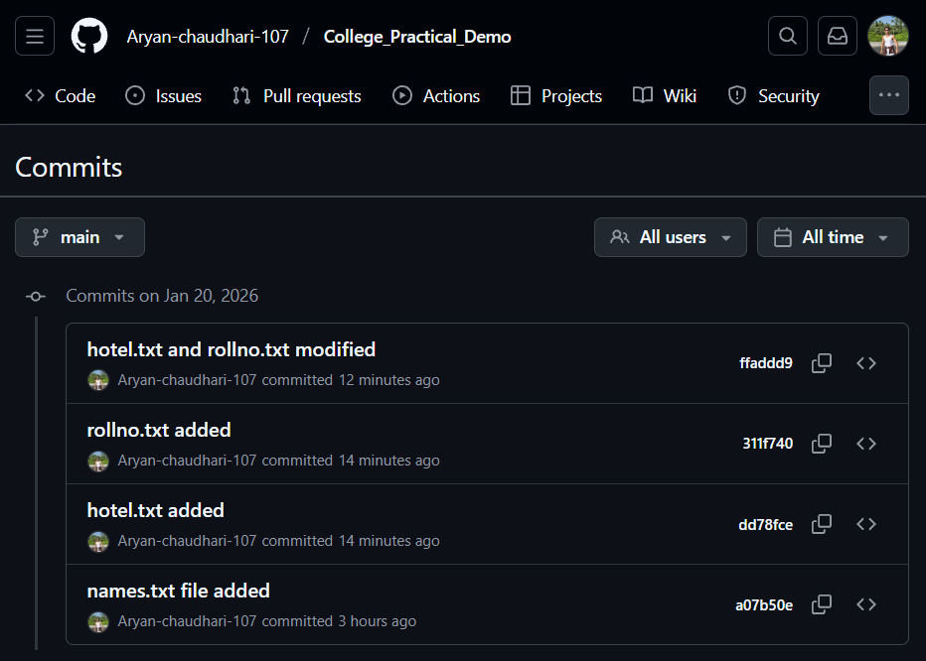

- Fork
Description: A fork is a personal copy of someone else’s repository created under your own GitHub account, allowing you to freely experiment, modify code, and propose changes without affecting the original project.
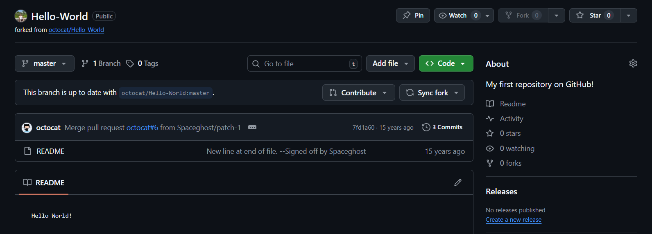
I have forked octocat/Hello-World successfully.

- git clone [url]
Description: Retrieves an entire repository from a hosted location via URL.
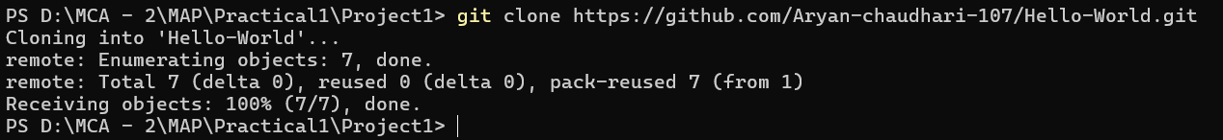
README.md Before:
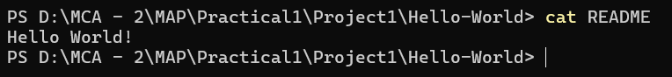
README.md After:
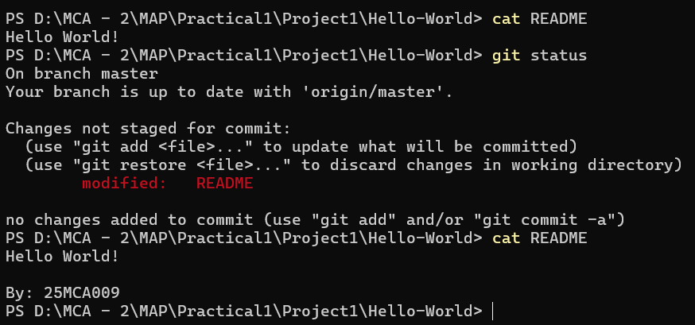

Section 6: Branch & Merge

“Do not commit directly on the main branch”
- git branch
Description: Used to list, create, or delete branches.
Does not switch to another branch.
- git checkout
Description: Used to switch between branches or restore files.
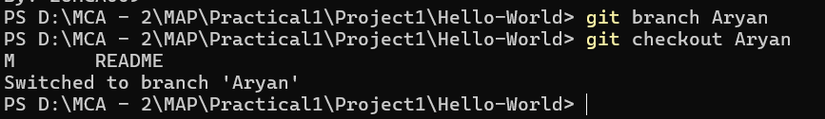

Add ., commited and pushed on Aryan branch
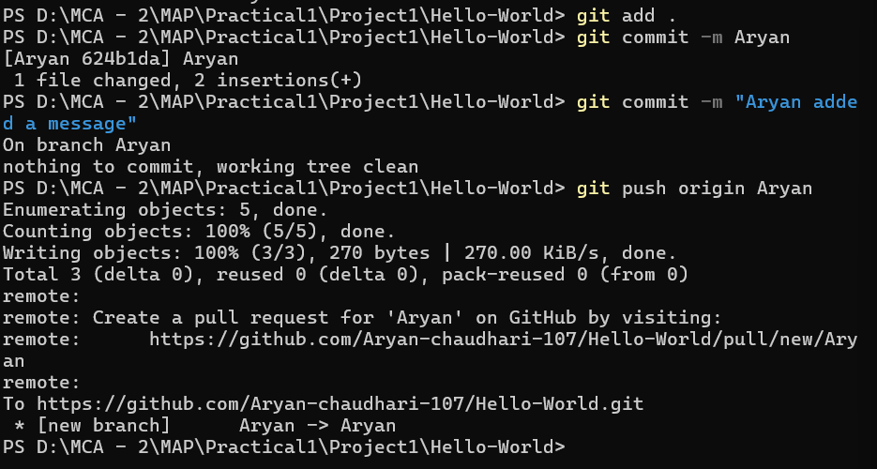
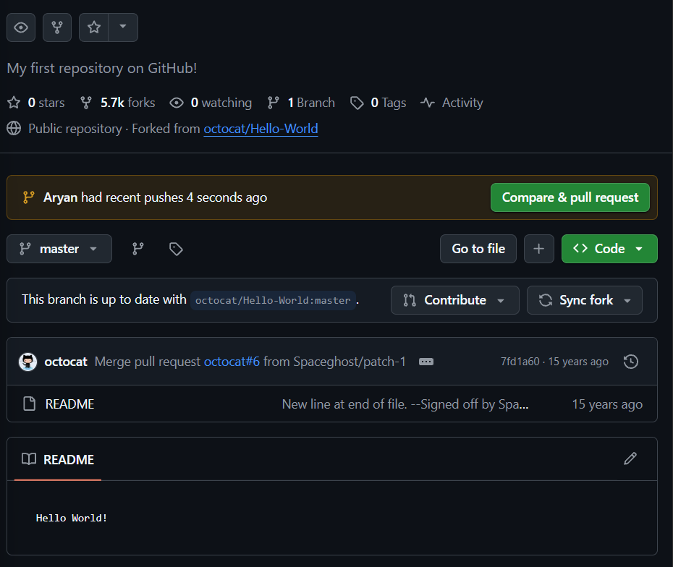

These are the changes (shown below):
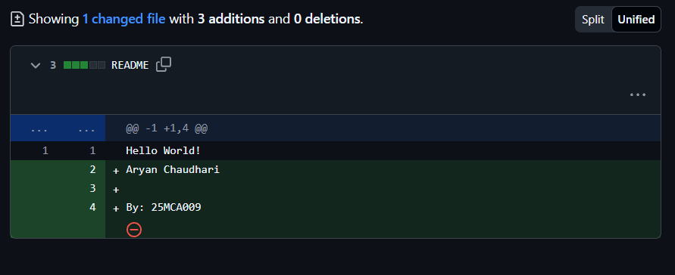
One pull request means one branch, one branch only open one request.

- Sync fork:
Description: The Sync fork button is used to update your forked repository with the latest changes from the original (upstream) repository.
Sync fork = fetch + merge (on GitHub UI)
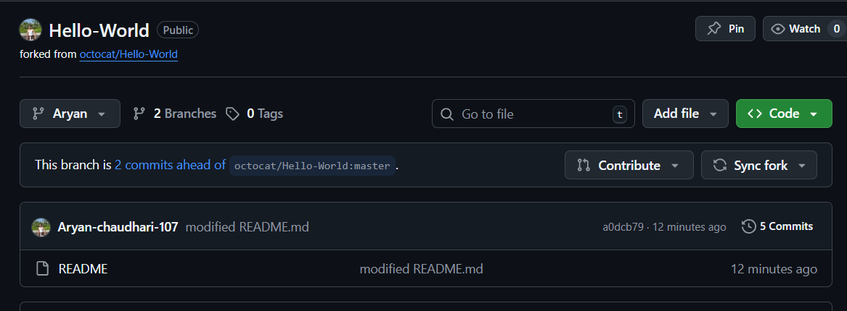

Also we can use commands like:

- git fetch upstream
Description: Downloads updates from a remote repository without merging them into your current branch.
- git merge upstream/main
Description: Combines another branch into the current branch.
- git pull upstream main
Description: Fetches updates from a remote repository and merges them into your current branch.

